Project Planning Phase
Project Planning Template (Product Backlog, Sprint Planning, Stories, Story Points)
Date | 12 October 2026
Team ID | 323103282097.aswija@gvpcew.ac.in
Project Name | ServiceNow Employee Raise Issue Portal
Maximum Marks | 5 Marks

Product Backlog, Sprint Schedule, and Estimation
Sprint assignments and story points below are proposed planning estimates for this project, not a record of measured team velocity or completed work.

Sprint | Functional Requirement (Epic) | User Story Number | User Story / Task | Story Points | Priority | Team Members
Sprint-1 | Issue Submission | USN-1 | As an employee, I can open the Raise Employee Issue form from the Employee Center portal. | 3 | High | Project team
Sprint-1 |  | USN-2 | As an employee, I can enter requester, category, subcategory, short description and issue state, then submit the issue. | 5 | High | Project team
Sprint-1 | Record Creation | USN-3 | As an employee/support user, I can have the submitted issue saved as a record in the Employee raises issues table. | 3 | High | Project team
Sprint-2 | Issue Classification | USN-4 | As an employee, I can classify the issue using the available categories and subcategories. | 3 | High | Project team
Sprint-2 | Issue Tracking | USN-5 | As a support user, I can review saved issue records with number, category, subcategory, state, priority, requester, assignment group and short description. | 5 | High | Project team
Sprint-2 | Portal Usability | USN-6 | As an employee, I can use the Raise Ticket button to navigate to the issue form through the custom widget. | 2 | Medium | Project team
Sprint-3 | Validation & Testing | USN-7 | As a project tester, I can verify that issue submission creates a record and that the record appears in the custom table. | 3 | High | Project team
Sprint-3 | Documentation | USN-8 | As a project team member, I can document the portal flow, record producer, custom widget and issue table for handover. | 2 | Medium | Project team

Project Tracker, Velocity & Burndown Chart
ServiceNow Employee Raise Issue Portal

Project Tracker, Velocity & Burndown Chart

Sprint | Total Story Points | Duration | Sprint Start Date | Sprint End Date (Planned) | Story Points Completed | Sprint Release Date (Actual)
Sprint-1 | 14 | 6 Days | To be scheduled | To be scheduled | To be measured | Not yet recorded
Sprint-2 | 10 | 6 Days | To be scheduled | To be scheduled | To be measured | Not yet recorded
Sprint-3 | 5 | 6 Days | To be scheduled | To be scheduled | To be measured | Not yet recorded

Note: The sprint durations and point totals are proposed estimates. Actual start/end dates, completed points and release dates should be filled in after the team executes each sprint.

Velocity
Velocity is the number of story points completed by the team during a sprint. Actual velocity cannot be calculated before a sprint is completed. For planning only, if 14 story points are planned over 6 working days:
Planned average work rate = 14 ÷ 6 ≈ 2.33 story points per day
This is a planning estimate, not measured team velocity.

Burndown Chart
Illustrative Sprint-1 burndown based on a 14-point plan. Replace the illustrative remaining-work values with daily actuals during execution.
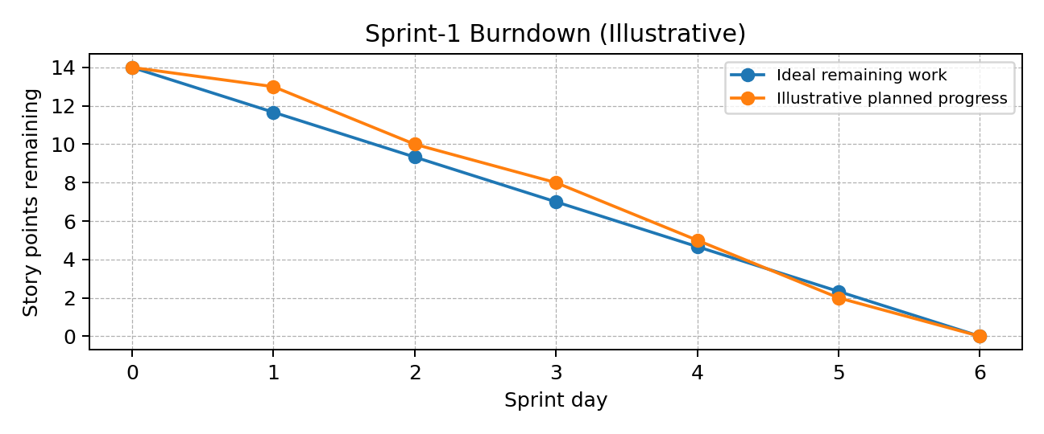
References
Agile planning concepts and burndown chart format are based on the structure of the supplied Project Planning Template. Project stories are tailored to the verified ServiceNow portal components.

